TEST 2

1. 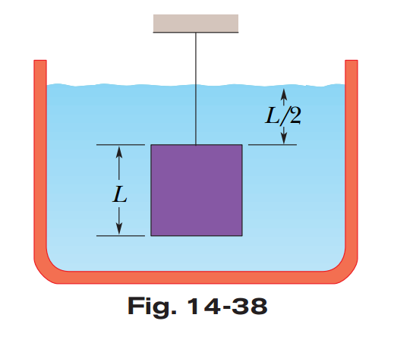In Fig. 14-38, a cube of edge length $L = 0.6 m$ and mass $450 kg$ is suspended by a rope in an open tank of liquid of density $1030 kg/m^{3}$. Find (a) the magnitude of the total downward force on the top of the cube from the liquid and the atmosphere, assuming atmospheric pressure is $1 atm$, (b) the magnitude of the total upward force on the bottom of the cube, and (c) the tension in the rope.
2. In a small room, people put a rice bag with mass $60kg$ in a chair with $4$ legs and its mass is $4kg$. Find the pressure at the interface of floor and a chair leg, each of chair leg has dimention $4x4 cm^{2}.$
3. 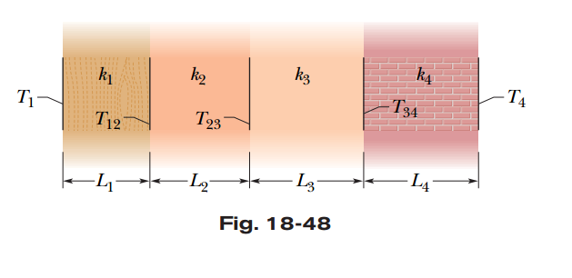A small electric immersion heater is used to heat $100 g$ of water for a cup of instant coffee. The heater is labeled “ $200 watts$” (it converts electrical energy to thermal energy at this rate). Calculate the time required to bring all this water from $23.0°C$ to $100°C$, ignoring any heat losses.
4. 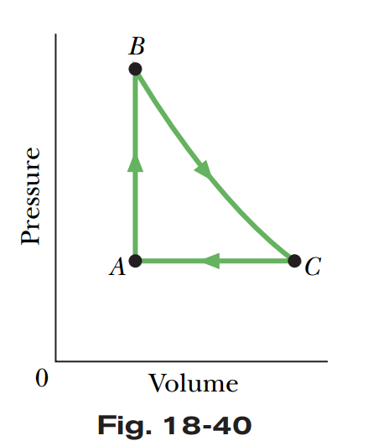Figure 18-48 shows (in cross section) a wall consisting of four layers, with thermal conductivities $k1= 0.06W/mK$, $k3=0.04W/mK$, and $k4= 0.12W/mK$ (k2 is unknown). The layer thicknesses are $L_{1}= 1.5 cm$, $L_{3}= 2.8 cm$, and $L_{4}= 3.5 cm$ ( $L2$ is unknown). The known temperatures are $T_{1}= 30°C, T_{12}= 25°C$, and $T_{4}=-10°C$. Energy transfer through the wall is steady. What is interface temperature $T_{34}$?
5. Gas held within a chamber passes through the cycle shown in Fig. 18-40. Determine the energy transferred by the system as heat during process $CA$ if the energy added as heat $Q_{AB}$ during process $AB$ is $20.0 J$, no energy is transferred as heat during process $BC$, and the net work done during the cycle is $15.0 J$.